Practical - 5

**AIM : Deployment of ML project using Flask.**

Deploying machine learning models with Flask in an ML lab is crucial because it enables researchers and data scientists to turn their models into accessible APIs or web applications. This facilitates collaboration, testing, and real-world usage of ML models, making them more practical and applicable to various domains. Flask provides a lightweight, flexible framework for building and deploying these interfaces quickly and efficiently.

**Task 1**: Install the required libraries

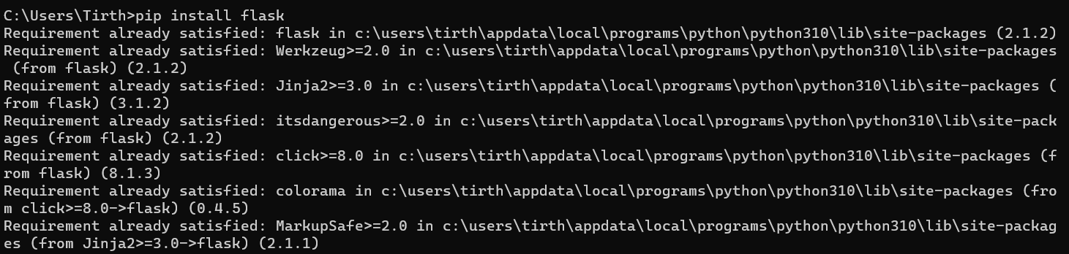

**Task 2:** Follow the steps described in theory material to deploy the model using Flask. Run the flask application to execute the deployed model.

Step :1 Create Template

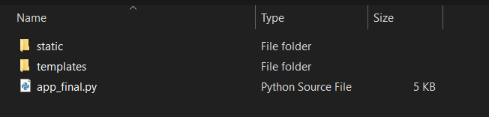

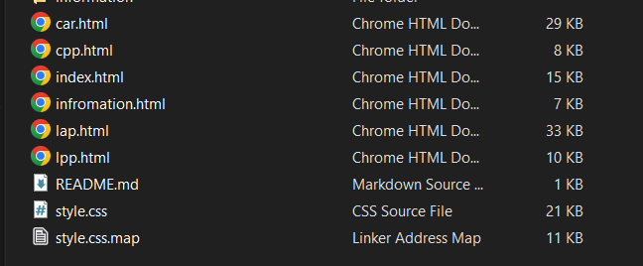

**User Interface :**



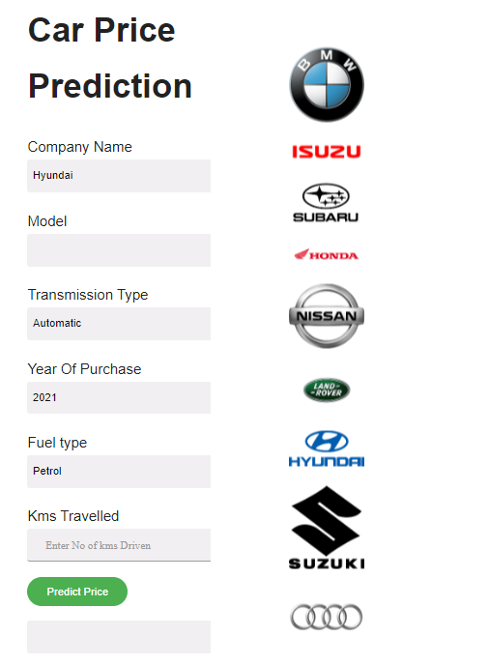

**Step: 2** Import the Model, Dataset, and Scalar objects into the project folder.

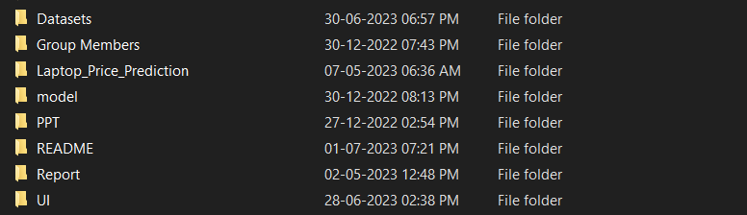

**Step: 3** Create the app.py file to serve the deployment

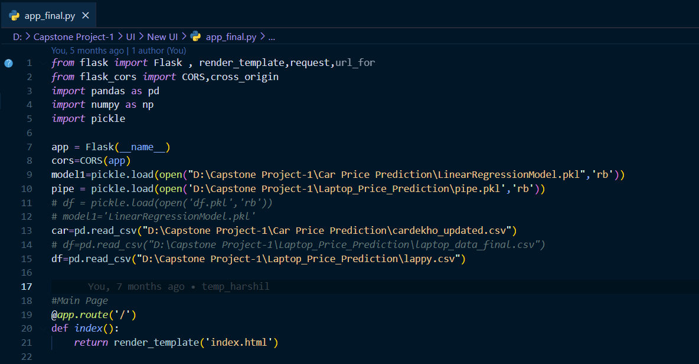

**Code : app.py**

from flask import Flask , render_template,request,url_for

from flask_cors import CORS,cross_origin

import pandas as pd

import numpy as np

import pickle

app = Flask(__name__)

cors=CORS(app)

model1=pickle.load(open("D:\Capstone Project-1\Car Price Prediction\LinearRegressionModel.pkl",'rb'))

car=pd.read_csv("D:\Capstone Project-1\Car Price Prediction\cardekho_updated.csv")

#Main Page

@app.route('/')

def index():

return render_template('index.html')

#Car Price Prediction

@app.route('/cpp')

def cpp():

#model=sorted(car['full_name'].unique())

car_models=sorted(car['full_name'].unique())

companies=(car['company'].unique())

transmission_type=sorted(car['transmission_type'].unique())

year=sorted(car['year'].unique(),reverse=True)

fuel_type=car['fuel_type'].unique()

km_driven=(request.form.get('km_driven'))

return render_template('car.html',companies=companies,car_models=car_models,transmission_type=transmission_type, year=year, fuel_type=fuel_type,km_driven=km_driven)

if __name__=="__main__":

app.run(debug=True)

**Output :**

